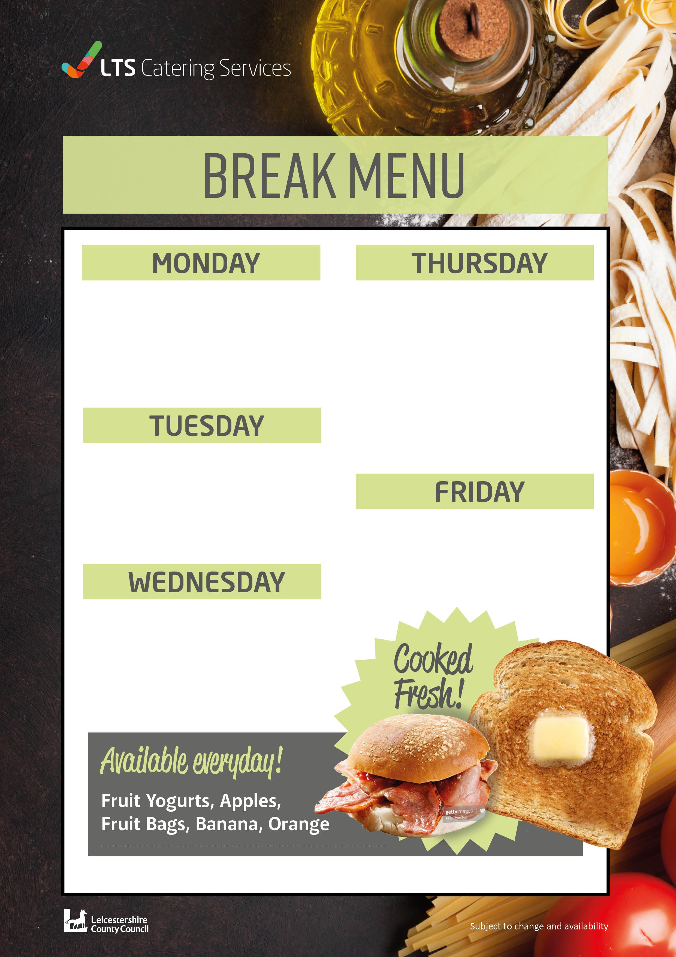
Bacon Roll Bagel £1.20
Pizza Crumpet 57p
Toast White or Wholemeal Bread 26p
Ham and Scrambled Egg Muffin or Sausage Cob £1.41
on weeks 1 and 3 Bagel 63p
Cheese on Toast 57p
Toast White or Wholemeal Bread 26p
Bacon Roll £1.20
Bagel 63p
Pitta Bread Cheese and Tomato Pizza £1.07
Toast White and Wholemeal Bread 26p
Bacon Roll Bagel £1.20
Pizza Pinwheel 57p
Toast White or Wholemeal Bread 26p

Ham and Cheese Toasties £1.72
Bagel 63p
Granola Fruit Pot 97p
Toast White and Wholemeal Bread 26p
W0391

