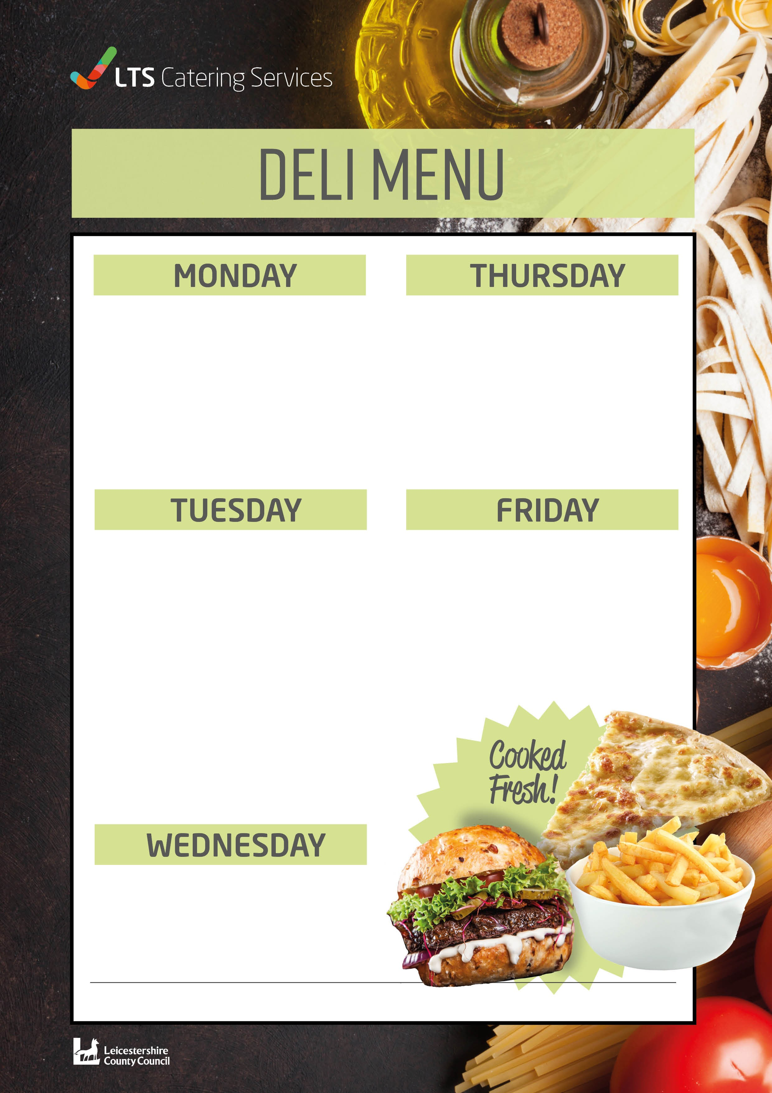
Assorted Sandwiches £1.72
Assorted Wraps £1.93
Assorted Baguettes £2.14
Pasta Bar £2.09
Pasta Bar with cheese £2.35

Assorted Sandwiches £1.72
Assorted Wraps £1.93
Assorted Baguettes £2.14
Pasta Bar £2.09
Pasta Bar with cheese £2.35
Jacket Potatoes £1.83
1 filling £2.09 2 Filling £2.35

Assorted Sandwiches £1.72
Assorted Wraps £1.93
Assorted Baguettes £2.14
Pasta Bar £2.09
Pasta Bar with cheese £2.35
Jacket Potatoes £1.83
1 filling £2.09 2 Filling £2.35

Assorted Sandwiches £1.72
Assorted Wraps £1.93
Assorted Baguettes £2.14
Pasta Bar £2.09
Pasta Bar with cheese £2.35
Jacket Potatoes £1.83
1 filling £2.09 2 Filling £2.35

Assorted Sandwiches £1.72
Assorted Wraps £1.93
Assorted Baguettes £2.14
Pasta Bar £2.09
Pasta Bar with cheese £2.35
Jacket Potatoes £1.83
1 filling £2.09 2 Filling £2.35

W0391

