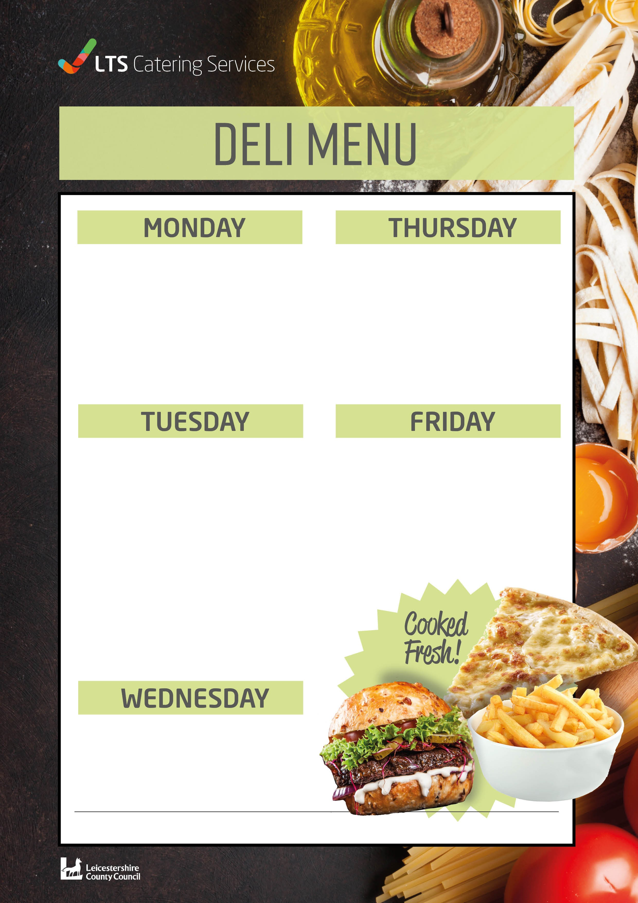
BBQ Chicken Thigh or Cajun Chicken Thigh £2.09
with a choice of Two Sides!
- Corn on the Cob
- Coleslaw
- Potato Wedges
Cheese Panini
Cheese and Tomato Panini
Pulled Pork Panini BBQ Chicken Panini Tuna Mayo Panini
See Board for Todays Choice
All Paninis £1.98
Cheese Panini
Cheese and Tomato Panini
Pulled Pork Panini BBQ Chicken Panini Tuna Mayo Panini
See Board for Todays Choice
All Paninis £1.98
Chicken Biryani Pockets Vegetable Biryani Pockets
with Mixed Salad, Coleslaw or Potato Salad £2.09
Tuna Pasta Bake £2.09
Served with Garlic Bread

Beef Burger Cheeseburger Vegetable Burger
Three Salmon Fish Fingers
All served in a Soft Bap with French Fries £2.09
W0391

