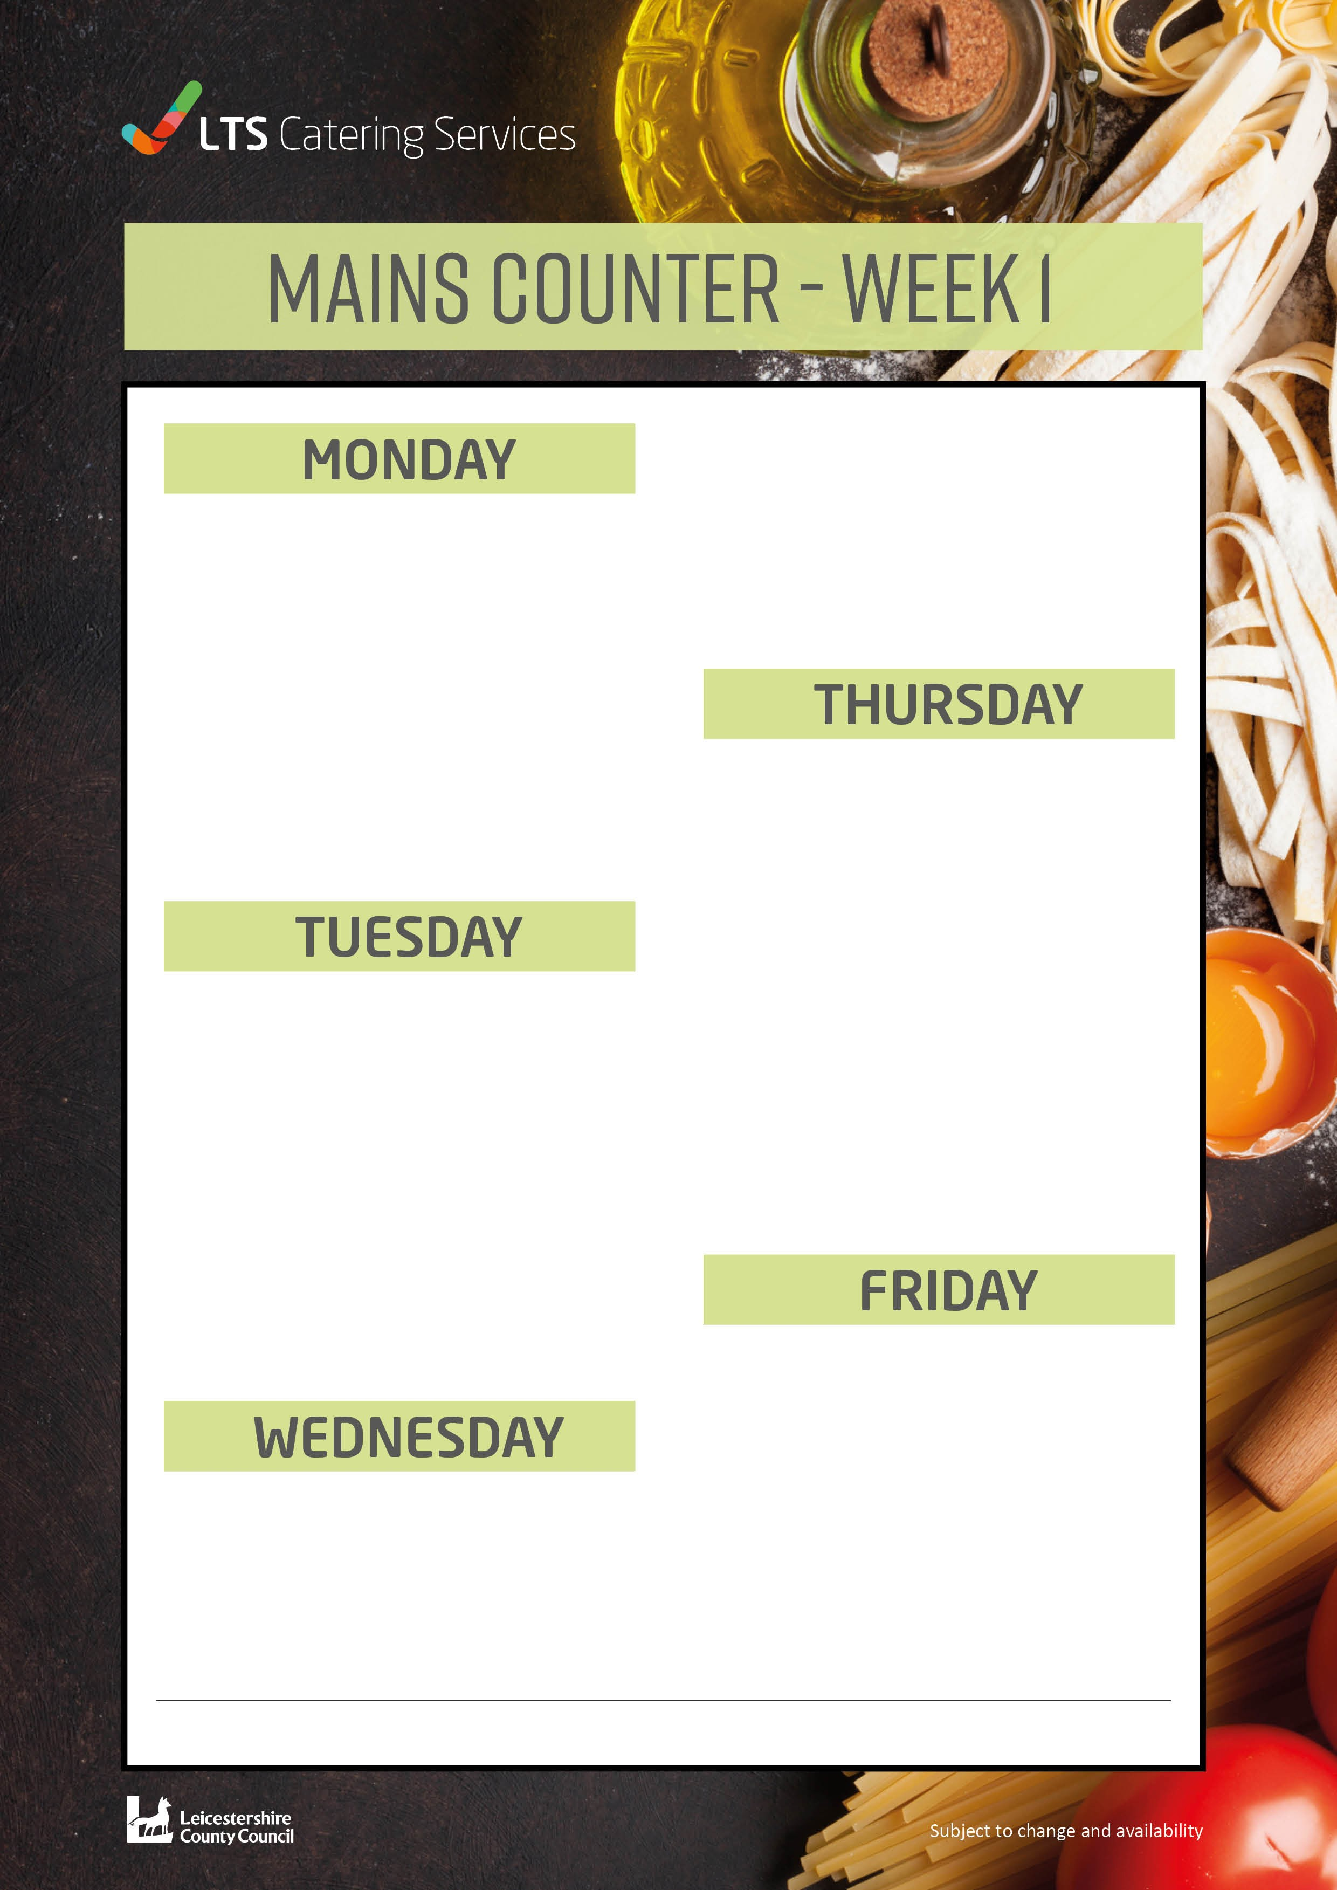
Chocolate Sponge and Chocolate Sauce 94p
Peach Crumble and Custard 94p
Cheesecake 78p
Apple Oaty Crumble and Custard 94p
Cornflake Tart and Custard 94p
Macaroni Cheese £2.09
Pasta in a cheese sauce topped with onions and sliced potato
Served with seasonal vegetables
Cottage Pie £2.09
Farm assured mince beef, onions in a gravy sauce Topped with a creamy mash potato and leeks Served with Cabbage and Carrots
Quorn Vegetable Stir-fry £2.09
Mixed peppers, onions, sweetcorn and green beans in a sweet chilli sauce
Served with Brown Rice
Homemade Chicken Pie £2.09
Farmed assured diced chicken in a creamy white sauce, sweetcorn and onions, topped with an herb wholemeal shortcrust pastry
Served with creamy mash potato, seasonal vegetables, and gravy
Homemade Cheese and Onion Pasty £2.09
In a puff pastry case
Served with creamy mash potato and seasonal vegetables
Chicken Tikka £2.09
Farm assured diced chicken in a mild spicy sauce with onions, peppers and a coriander garnish
Served with long Brown rice and naan bread
Quorn Tikka £2.09
Diced quorn in a mild spicy sauce with peppers, onions and a coriander garnish
Served with Brown rice and naan bread
Battered Fish Portion £2.09
Served with french fries, baked beans or peas
Homemade Cheese and Tomato Pizza £2.09
Served with french fries, beans or peas
Brunch Lunch £2.09
Choose 5 from the following: Bacon, Sausage, Hash Brown, Beans,
Tomatoes, Egg or Mushrooms
W0391

