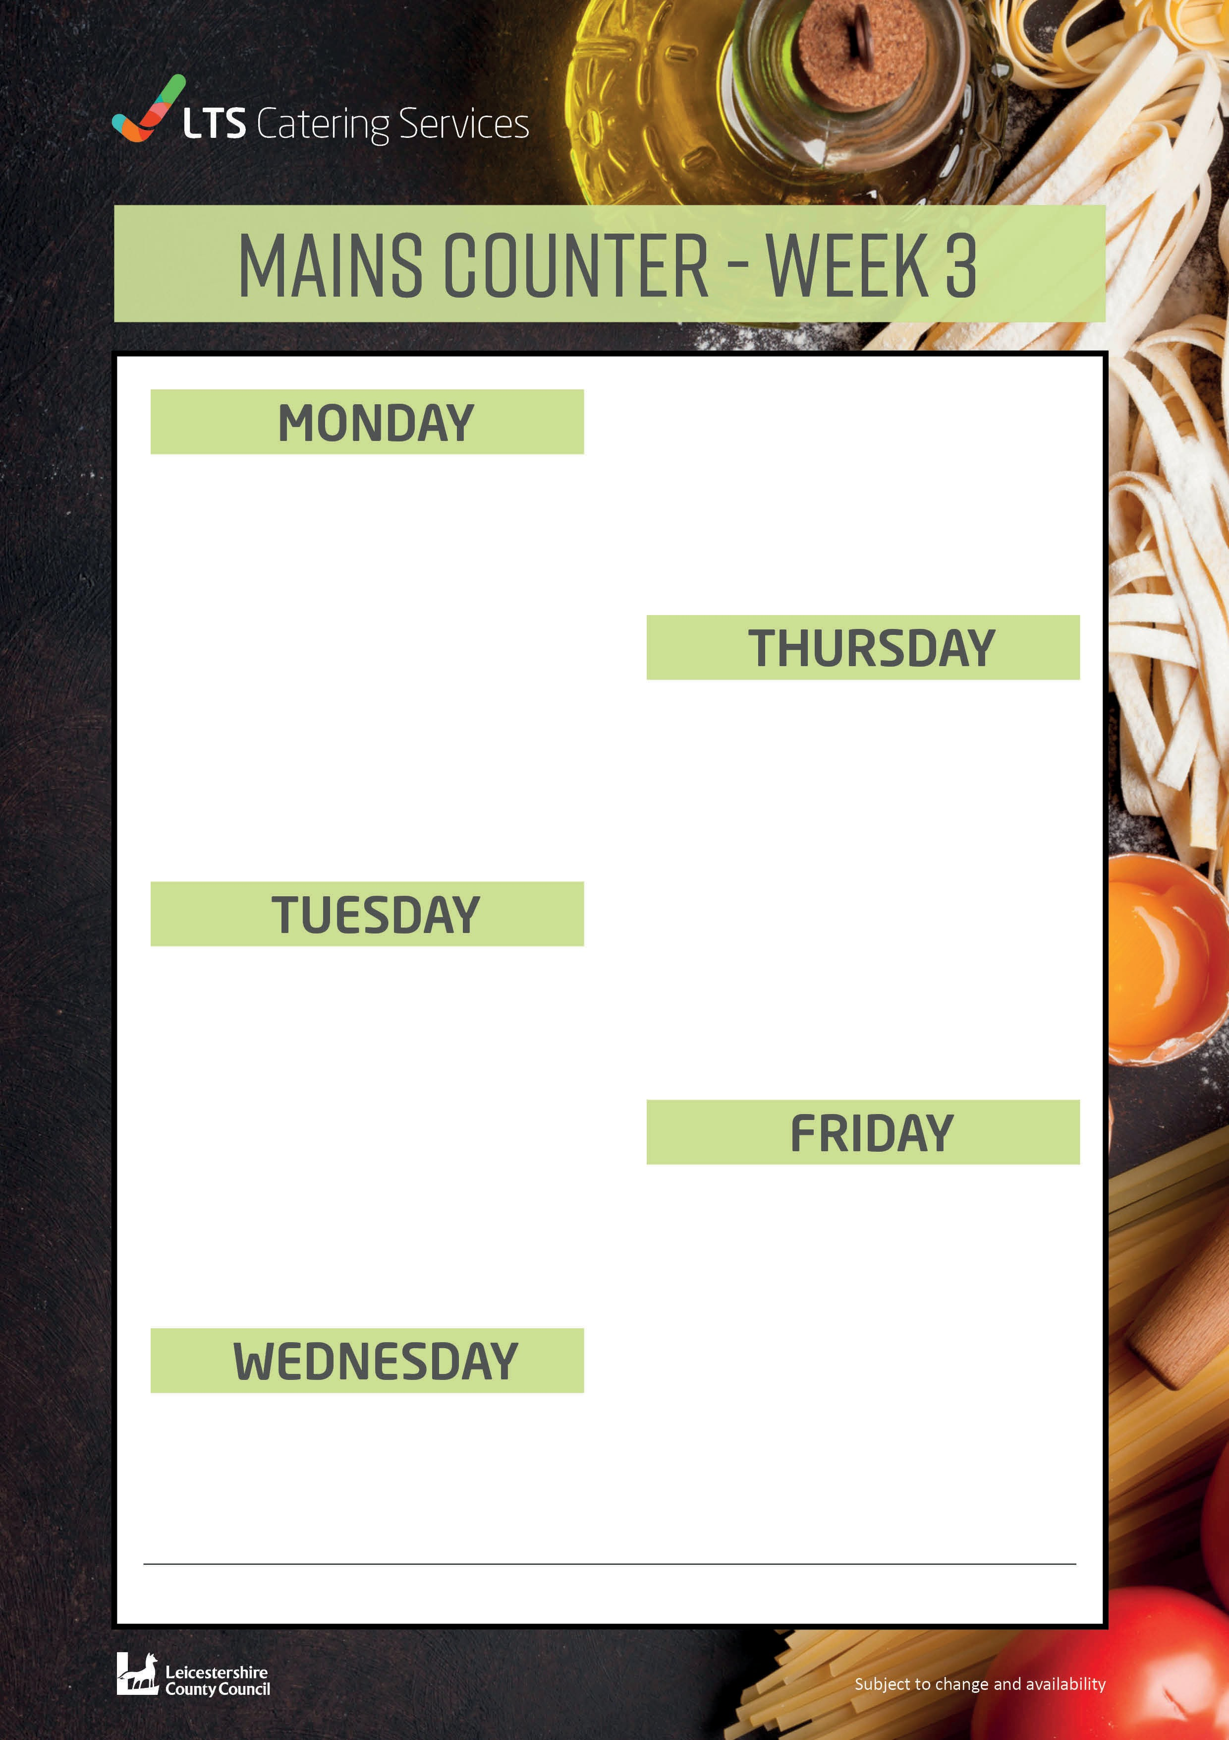
Apple Pie and Custard 94p
Roast Pork £2.09
Farmed assured pork, served with roast potatoes,
sage and onion stuffing, Seasonal vegetables
Fruit Salad Trifle 78p
Vegetarian Korma£2.09
Quorn pieces cooked in mild curry sauce Served with onions, peppers, turmeric rice and naan bread
Peach Melba Traybake 68p
Cauliflower and Broccoli Leek Bake £2.09
Vegetables cooked in a cheese sauce Served with roast potatoes
Beef Lasagne £2.09
Farmed assured minced beef cooked in a garlic
tomato sauce with peppers and onions.
Served with homemade garlic bread and a mixed salad
Vegetable Lasagne £2.09
Minced Quorn in a garlic tomato sauce.
Brunch Lunch £2.09
Choose 5 from the following: Bacon, Sausage, Hash Browns, Beans, Tomatoes, Toast, Egg or Mushrooms
Served with homemade garlic bread and a mixed salad.
Vegetarian Brunch £2.09
Choose 5 from the following: Vegetarian Sausage, Hash Brown, Beans,
Tomatoes, Toast, Egg, or Mushrooms
Chicken Korma £2.09
Farmed assured chicken pieces cooked in a mild
curry sauce
Served with onions, peppers, and turmeric rice
Chocolate and Beetroot Sponge
Served with custard 94p
Battered Fish Portion £2.09
Served with chips, baked beans, or peas
Chicken Nuggets £2.09
Served with French fries, beans or peas
Chocolate Sponge and Chocolate Sauce 94p
W0391

