

Closed Circuit Television
(CCTV) Policy

Spring 2024

Review Date: | Spring 2024 | Reviewed & adopted by: | Trustees
Next Review Due: | Spring 2027 | Updated by: | R. Mays
Mid-Reviews (statutory):
Document No: | POL-SCH-001 | The information contained on this document is considered proprietary to East Midlands Education Trust in that these items and processes were developed at private expense. This information shall not be released, disclosed, or duplicated.

Table of Contents

1. Purpose 2
2. Scope 2
3. Location of Cameras 3
4. Covert Recording 3
5. Storage and retention of CCTV recordings 3
6. CCTV maintenance 4
7. Access and disclosure of images/recordings to 1st parties 4
8. Subject Access Requests 4
9. Access and disclosure of images/recordings to 3rd parties 5
10. Data Protection Impact Assessments 5
11. Complaints procedure 5
Appendix 1: Location of CCTV cameras 6
Appendix 2: Responsibilities 7
Appendix 3: Access to CCTV Images/Recordings 7
Appendix 4: CCTV Access Log 8

Purpose

  - The purpose of this policy is to regulate the management, operation and use of the CCTV system (Closed Circuit Television) at the school.

  - CCTV systems are installed for the purpose of:
    - Protecting the school buildings and assets, both during and after school hours
    - Help maintain a secure and safe environment for students, staff and others, which supports their welfare and wellbeing
    - Deter poor and anti-social behaviour
    - Assisting in the prevention, investigation and detection of crime
    - Assisting in the apprehension and prosecution of offenders, including use of images as evidence in criminal proceedings
    - Assisting in the investigation of breaches of its codes of conduct and policies by staff, pupils and contractors and where relevant and appropriate investigating complaints
  - The CCTV system is owned and operated by the school, the deployment of which is determined by the school’s leadership team in accordance with the purposes set out above.

  - This policy is subject to a full review every 3 years.

  - The CCTV system will be registered with the Information Commissioner under the terms of the Data Protection Act and will seek to comply with the requirements of the Data Protection Act, GDPR and the Commissioner's Code of Practice

Scope

  - This policy relates to the location, use of CCTV and the monitoring, recording and subsequent use of such recorded material.
  - Recognisable images captured by CCTV systems are ‘personal data’. The CCTV system will be registered with the Information Commissioner under the terms of the Data Protection Act and will comply with the requirements of the Data Protection Act and GDPR.

  - The school complies with the Information Commissioner’s Office (ICO) Guidance on Video Surveillance to ensure it is used responsibly and safeguards both trust and confidence in its use. The ICO’s Guidelines is published here.

  - All CCTV systems and associated equipment must be compliant with this policy.

  - This policy does not apply to any webcam systems located in classrooms or meeting rooms which are used to assist with the use of audio-visual equipment or used for the primary purpose of teaching and learning.

  - This policy applies to all school staff and contractors who operate, maintain, or supervise the operation of, the CCTV system.

Location of Cameras
  - CCTV systems are installed in and around the school building entrances, carparks, perimeters and internal areas such as reception. A site map/location list indicating the location of cameras is attached as an appendix to this policy.
  - The planning and design of CCTV endeavours to ensure that the system will give maximum effectiveness and efficiency, but it is not guaranteed that the system will cover or detect every single incident taking place in the areas of coverage.
  - The cameras are sited so that they only capture images relevant to the purposes for which they have been installed, and care will be taken to ensure that reasonable privacy expectations are not violated. The school will ensure that the location of equipment is carefully considered to ensure that the images captured comply with the legislation.
  - The school will make every effort to position the cameras so that their coverage is restricted to the school premises.
  - CCTV cameras are installed in such a way that they are not hidden from view. Warning signs will be clearly and prominently placed at the main external entrance to the school. In other areas where CCTV is used, the school will ensure that there are prominent signs placed within the controlled area.

Covert Recording
  - Covert recording is the recording of an individual without their knowledge. Covert recording must:
    - Only be undertaken in exceptional circumstances, for example to prevent or detect an unlawful act or other serious misconduct, and if is proportionate i.e. there is no other reasonable, less intrusive means of achieving those purposes
    - Not be undertaken without the prior written authorisation in the form of the Home Office Application of Directed Surveillance which must be sent to and approved by the Head Teacher. All decisions to engage in covert recording will be documented and retained.
    - Focus only on the suspected unlawful activity or suspected serious misconduct and information obtained which is not relevant will be disregarded and where reasonably possible, deleted
    - Only be carried out for a limited and reasonable period consistent with particular purpose of the recording and will not continue after the investigation is completed.

Storage and retention of CCTV recordings
  - CCTV images are not to be retained for longer than necessary, taking into account the purposes for which they are being processed. Data storage is automatically managed by the CCTV digital records which overwrite historical data in chronological order with a standard retention period of 31 days.

  - Provided that there is no legitimate reason for retaining the CCTV images (such as for use in disciplinary and/or legal proceedings), the images will be erased following the expiration of the retention period.

  - Legitimate reasons for retaining data include where the image identifies an issue or is retained specifically in the context of an investigation or prosecution of that issue. Where data is retained outside of the retention period, a record must be made in the school GDPR area on Teams, all fields must be completed to ensure an accurate record on where the information is held, for what purpose and who has access to this.

  - All retained CCTV images will be stored securely.

CCTV maintenance

  - The maintenance of the CCTV System should be carried out by the on-site technician or a qualified external supplier with permission from the head teacher.

Access and disclosure of images/recordings to 1st parties

  - The CCTV footage should only be accessed by the first party for the purposes stated in section 1.2 of this policy. Access for personal use or any other reason should be considered a violation of this policy.

  - A list of authorised personnel who have access to the CCTV system must be held and kept up to date at all times. This list should be limited to a minimum number of users who have the authority to access the CCTV system for data protection and security reasons. Only authorised personnel should access to the CCTV system.

  - Every instance where the CCTV system is accessed to view any live footage or recordings must be logged. This is to help ensure that the CCTV system is only used for the intended purposes stated in section 1.2 of this policy. Details of this log must include:

- The name of the authorised user accessing the CCTV system.
- Requester’s name.
- Reason for accessing the CCTV system
- Date and time when the CCTV system was accessed.
- See appendix 4 for an example

Subject Access Requests

  - Individuals (Data Subjects) have the right to request CCTV footage relating to themselves under the DPA 2018 and the GDPR.

  - Data Subjects can exercise their rights by submitting a request to the Local Data Protection Representative or Head teacher in writing. Individuals submitting requests for access will be asked to provide sufficient information to enable footage relating to them to be identified, for example, time, date and location.

  - No charge can be made for access to personal data that is not contained within an education record but the School reserves the right to cover its communication costs e.g. photocopying, postage, in which case a fees notice will be sent to the requestor.

  - The school will respond to requests within 30 days (in line with GDPR regulations) of receiving the request but if a request is received outside of the school term this may not be possible. The period for responding to the request may be extended by two further months where necessary, taking into account the complexity and number of the requests.

  - The school reserves the right to refuse access to CCTV footage where this would prejudice the legal rights of other individuals or jeopardise an on-going investigation.

Access and disclosure of images/recordings to 3rd parties

  - Third party requests for access will usually only be considered in line with the GDPR and DPA 2018 in the following categories:
    - Legal representative of the Data Subject
    - Law enforcement agencies including the Police
    - Disclosure required by law or made in connection with legal proceedings
    - HR staff responsible for employees and staff responsible for pupil disciplinary and complaints investigations and related proceedings.

  - The Head teacher will disclose recorded images to law enforcement agencies including the Police once in possession of a form certifying that the images are required for either: an investigation concerning national security; the prevention or detection of crime; or the apprehension or prosecution of offenders, and that the investigation would be prejudiced by failure to disclose the information. Where images are sought by other bodies/agencies with a statutory right to obtain information, evidence of that statutory authority will be sought before CCTV images are disclosed.

  - Every disclosure of CCTV images is recorded by the school and contains:
- The name of the police officer or other relevant person in the case of other agencies/bodies receiving the copy of the recording
- Brief details of the images captured by the CCTV to be used in evidence or for other purposes permitted by this policy
- The crime reference number where relevant
- Date and time the images were handed over to the police or other body/agency.

  - Data may be used within the school’s discipline and grievance procedures as required and will be subject to the usual confidentiality requirements of those procedures.

Data Protection Impact Assessments

  - CCTV has the potential to be privacy intrusive. The school will complete a Data Protection Impact Assessment when:
    - Installing CCTV cameras
    - Moving CCTV cameras.

  - The school must consider the privacy issues involved with using new or relocating surveillance systems to ensure that the use is necessary, proportionate and address the pressing need identified.

  - Guidance on impact assessments and a template created by the ICO and CCS can be found here.

Complaints procedure

  - Any complaints relating to the CCTV system should be directed to the Head Teacher of the school in accordance with the EMET Complaints Policy.

Appendix 1: Location of CCTV cameras

Castle Donington College
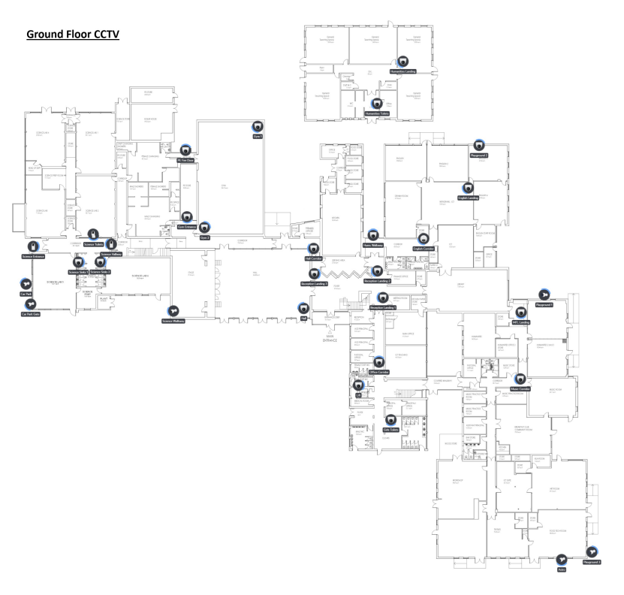

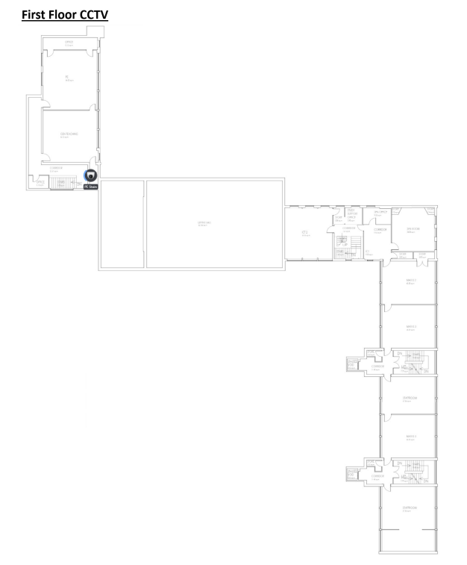

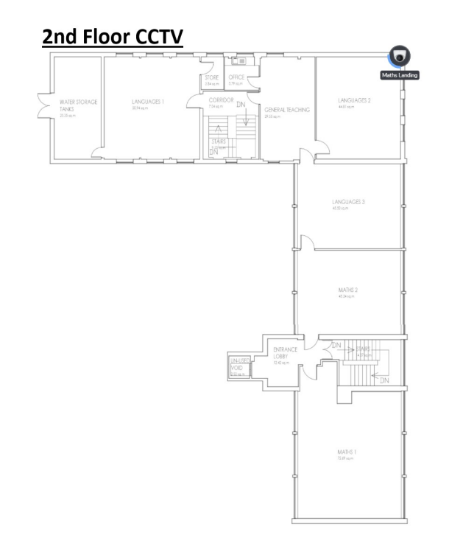

Appendix 2: Responsibilities

The Trust has the overall responsibility for this policy but the day-to-day responsibility for overseeing the implementation and compliance with this policy has been delegated as per the table below:

Castle Donington College
Mount Pleasant
Castle Donington
Derby
DE74 2LN

Role | Responsibility
Head Teacher | To ensure the CCTV system including camera specifications for new installations complies with the law and this Policy.
SLT | Policy is reviewed/updated and complied with. Review footage requests submitted (appendix 4)
IT Network Manager / Site Team | Administer CCTV software accounts and maintenance/operation of the system. Implement additional camera requests where approved. Administer footage requests submitted (appendix 4)

Appendix 3: Access to CCTV Images/Recordings

The following staff have access to CCTV Images/Recordings:

Role | Access Rights
Head Teacher | All
SLT | All
Heads of Year and Pastoral Leaders | View only
Site Team | View
IT Network Manager | All  Administer accounts

Appendix 4: CCTV Access Log

Incident name
Date of check
Time of check
Camera id and location
Operational period (1-24 hours)
Name and position of person authorised to provide the information
Name and position of person making the request for information
Any third party/outside agency provided with copy of information
Reason for the request
Action taken

Note: Accessed information should be retained/destroyed in accordance with the CCTV policy.
Signature of authorised person ………………………………………………………………………………

Page 8 of 8 CCTV Policy POL-SCH-001

