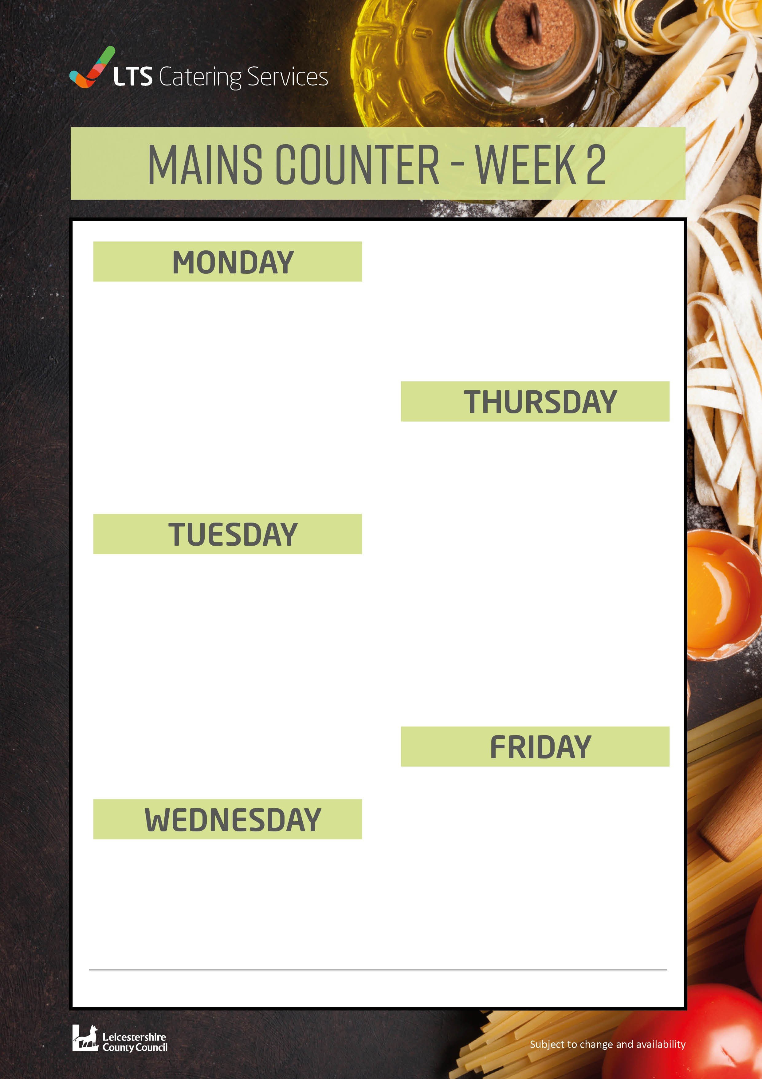

Carrot Cake 78p

BBQ Chicken Wrap £2.09

Diced chicken cooked in a tomato spicy sauce with peppers and onions wrapped in a soft tortilla wrap

Homemade Chicken Pie £2.09

Farmed assured chicken pieces in white sauce, onions and sweetcorn

Vegetarian Brunch £2.09

Choose 5 from the following: Vegetarian Sausage, Hash Brown, Beans,

Tomatoes, Toast, Egg or Mushrooms

Chocolate and Pear Sponge and Chocolate Sauce

Toad in the Hole £2.09

Two pork sausages in a large Yorkshire pudding Served with creamy mash potato and seasonal vegetables

Vegetarian Toad in the Hole £2.09

Two quorn sausage in a large Yorkshire pudding Served with creamy mash potato, seasonal vegetables and gravy

Chocolate and Pear Sponge

Served with Custard **94p**

Topped with an herb wholemeal shortcrust

pastry

Served with creamy mash potato and seasonal vegetables

Homemade Cheese and Onion Pasty £2.09

Served in a puff pastry case, mash potato,

seasonal vegetables and gravy

Mixed Berry Oat Crumble Served with custard 94p

BBQ Vegetable Wrap £2.09

Diced Quorn pieces cooked in a tomato s spicy sauce with peppers and onions wrapped in a soft tortilla wrap

Served with Coleslaw and a Green Leaf Salad

Chicken Goujons £2.09

Served with chips, baked beans, or peas

Quorn Dippers £2.09

Five pieces Served with chips and baked beans

Brunch Lunch £2.09

Choose 5 from the following: Bacon, Sausage, Hash Brown, Beans, Tomatoes, Toast, Egg or Mushrooms

Chocolate Sponge and Chocolate Sauce 94p

W0391